Ideation Phase
Brainstorm & Idea Prioritization Template

Date | 18 June 2026
Project Name | ShopEZ
Student Name | Ch.Sai Shruthi

Brainstorm & Idea Prioritization Template:

Brainstorming is an essential step in the development of the ShopEZ Online Shopping Platform, enabling the project team to identify user needs, explore innovative ideas, and design effective solutions for modern e-commerce challenges. It provides an open and collaborative environment where team members can freely share ideas related to product browsing, secure authentication, shopping cart management, order processing, payment integration, and administrative features.
During the brainstorming process, the team focuses on generating a wide range of ideas without immediate evaluation, encouraging creativity and innovation. These ideas are then analyzed, discussed, and prioritized based on factors such as feasibility, user value, technical complexity, business impact, and implementation effort. This structured approach helps the team identify the most valuable features, define the project scope, and develop a scalable, user-friendly, and secure e-commerce platform that enhances customer satisfaction and streamlines online shopping experiences.

Step-1: Team Gathering, Collaboration and Select the Problem Statement
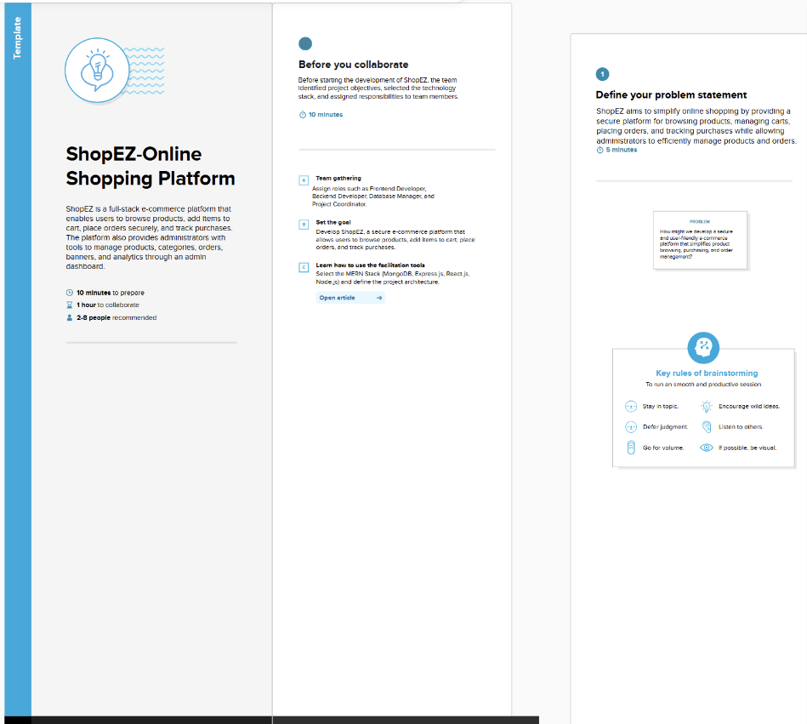

Step-2: Brainstorm, Idea Listing and Grouping
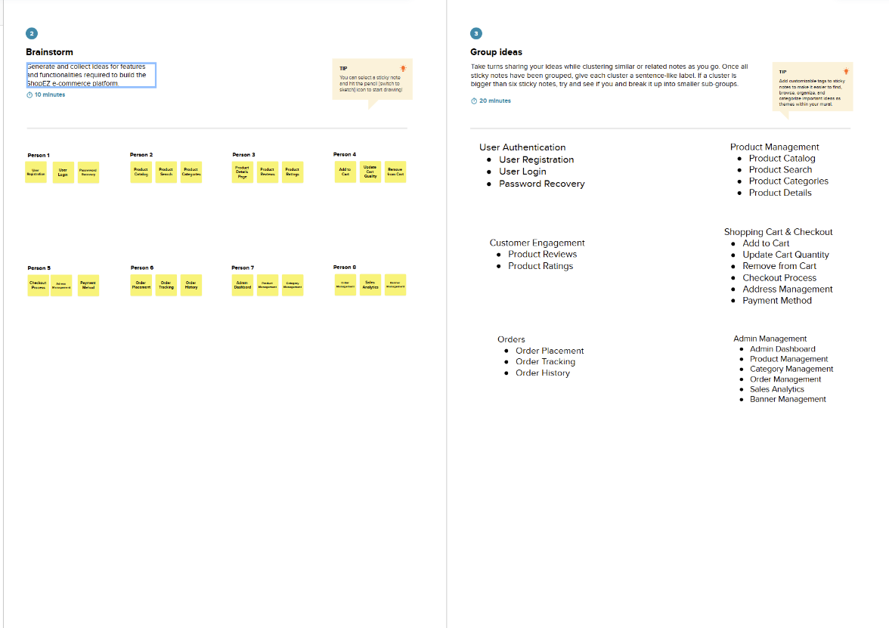

Step-3: Idea Prioritization

